**LEARNING**

An agent is **learning** if it improves its performance on future tasks after making observations about the world.

Why would we want an agent to learn? If the design of the agent can be improved, why wouldn’t the designers just program in that improvement to begin with? There are three main reasons.

* First, the designers cannot anticipate all possible situations that the agent might find itself in. For example, a robot designed to navigate mazes must learn the layout of each new maze it encounters.
* Second, the designers cannot anticipate all changes over time; a program designed to predict tomorrow’s stock market prices must learn to adapt when conditions change from boom to bust.
* Third, sometimes human programmers have no idea how to program a solution themselves. For example, most people are good at recognizing the faces of family members, but even the best programmers are unable to program a computer to accomplish that task, except by using learning algorithms.

**FORMS OF LEARNING**

Any component of an agent can be improved by learning from data. The improvements, and the techniques used to make them, depend on four major factors:

• Which *component* is to be improved.

• What *prior knowledge* the agent already has.

• What *representation* is used for the data and the component.

• What *feedback* is available to learn from.

Learning a (possibly incorrect) general function or rule from specific input–output pairs is called **inductive** **learning**.

**Feedback to learn from**

There are three *types of feedback* that determine the three main types of learning:

* In **unsupervised learning** the agent learns patterns in the input even though no explicit feedback is supplied. The most common unsupervised learning task is **clustering**: detecting potentially useful clusters of input examples. For example, a taxi agent might gradually develop a concept of “good traffic days” and “bad traffic days” without ever being given labeled examples of each by a teacher.
* In **reinforcement learning** the agent learns from a series of reinforcements—rewards or punishments. For example, the lack of a tip at the end of the journey gives the taxi agent an indication that it did something wrong. The two points for a win at the end of a chess game tells the agent it did something right. It is up to the agent to decide which of the actions prior to the reinforcement were most responsible for it.
* In **supervised learning** the agent observes some example input–output pairs and learns a function that maps from input to output. In component 1 above, the inputs are percepts and the output are provided by a teacher who says “Brake!” or “Turn left.” In component 2, the inputs are camera images and the outputs again come from a teacher who says “that’s a bus.” In 3, the theory of braking is a function from states and braking actions to stopping distance in feet. In this case the output value is available directly from the agent’s percepts (after the fact); the environment is the teacher.

**LEARNING EXAMPLE: DECISION TREES**

Decision tree induction is one of the simplest and yet most successful forms of machine learning. We first describe the representation—the hypothesis space—and then show how to learn a good hypothesis.

**The decision tree representation**

A **decision tree** represents a function that takes as input a vector of attribute values and returns a “decision”—a single output value. The input and output values can be discrete or continuous

* Decision Tree is a **Supervised learning technique**that can be used for both classification and Regression problems, but mostly it is preferred for solving Classification problems. It is a tree-structured classifier, where**internal nodes represent the features of a dataset, branches represent the decision rules** and **each leaf node represents the outcome.**
* In a Decision tree, there are two nodes, which are the **Decision Node** and**Leaf Node.** Decision nodes are used to make any decision and have multiple branches, whereas Leaf nodes are the output of those decisions and do not contain any further branches.
* The decisions or the test are performed on the basis of features of the given dataset.
* ***It is a graphical representation for getting all the possible solutions to a problem/decision based on given conditions.***
* It is called a decision tree because, similar to a tree, it starts with the root node, which expands on further branches and constructs a tree-like structure.
* In order to build a tree, we use the **CART algorithm,** which stands for **Classification and Regression Tree algorithm.**
* A decision tree simply asks a question, and based on the answer (Yes/No), it further split the tree into subtrees.
* Below diagram explains the general structure of a decision tree:



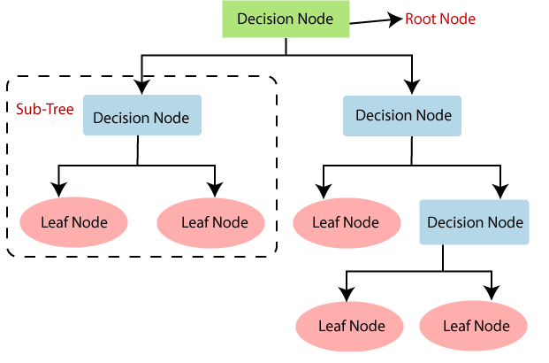

Why use Decision Trees?

There are various algorithms in Machine learning, so choosing the best algorithm for the given dataset and problem is the main point to remember while creating a machine learning model. Below are the two reasons for using the Decision tree:

* Decision Trees usually mimic human thinking ability while making a decision, so it is easy to understand.
* The logic behind the decision tree can be easily understood because it shows a tree-like structure.

## Decision Tree Terminologies

• **Root Node:** Root node is from where the decision tree starts. It represents the entire dataset, which further gets divided into two or more homogeneous sets.

• **Leaf Node:** Leaf nodes are the final output node, and the tree cannot be segregated further after getting a leaf node.

• **Splitting:** Splitting is the process of dividing the decision node/root node into sub-nodes according to the given conditions.

• **Branch/Sub Tree:** A tree formed by splitting the tree.

• **Pruning:** Pruning is the process of removing the unwanted branches from the tree.

• **Parent/Child node:** The root node of the tree is called the parent node, and other nodes are called the child nodes.

**How does the Decision Tree algorithm Work?**

In a decision tree, for predicting the class of the given dataset, the algorithm starts from the root node of the tree. This algorithm compares the values of root attribute with the record (real dataset) attribute and, based on the comparison, follows the branch and jumps to the next node.

For the next node, the algorithm again compares the attribute value with the other sub-nodes and move further. It continues the process until it reaches the leaf node of the tree. The complete process can be better understood using the below algorithm:

* **Step-1:** Begin the tree with the root node, says S, which contains the complete dataset.
* **Step-2:** Find the best attribute in the dataset using **Attribute Selection Measure (ASM).**
* **Step-3:** Divide the S into subsets that contains possible values for the best attributes.
* **Step-4:** Generate the decision tree node, which contains the best attribute.
* **Step-5:** Recursively make new decision trees using the subsets of the dataset created in step -3. Continue this process until a stage is reached where you cannot further classify the nodes and called the final node as a leaf node.

**Example:** Suppose there is a candidate who has a job offer and wants to decide whether he should accept the offer or Not. So, to solve this problem, the decision tree starts with the root node (Salary attribute by ASM). The root node splits further into the next decision node (distance from the office) and one leaf node based on the corresponding labels. The next decision node further gets split into one decision node (Cab facility) and one leaf node. Finally, the decision node splits into two leaf nodes (Accepted offers and Declined offer). Consider the below diagram:

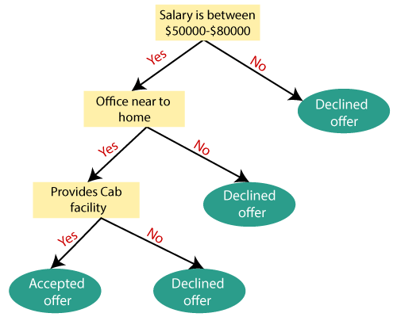

## Attribute Selection Measures

While implementing a Decision tree, the main issue arises that how to select the best attribute for the root node and for sub-nodes. So, to solve such problems there is a technique which is called as **Attribute selection measure or ASM.**By this measurement, we can easily select the best attribute for the nodes of the tree. There are two popular techniques for ASM, which are:

* **Information Gain**
* **Gini Index**

### 1. Information Gain:

* Information gain is the measurement of changes in entropy after the segmentation of a dataset based on an attribute.
* It calculates how much information a feature provides us about a class.
* According to the value of information gain, we split the node and build the decision tree.
* A decision tree algorithm always tries to maximize the value of information gain, and a node/attribute having the highest information gain is split first. It can be calculated using the below formula:

1. Information Gain= Entropy(S)- [(Weighted Avg) *Entropy(each feature)

**Entropy:** Entropy is a metric to measure the impurity in a given attribute. It specifies randomness in data.

*Entropy is defined as****the randomness or measuring the disorder of the information being processed in Machine Learning****. Further, in other words, we can say that entropy is the machine learning metric that measures the unpredictability or impurity in the system.*

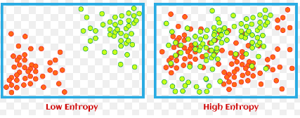

Entropy can be calculated as:

Entropy(s)= -P(yes)log2 P(yes)- P(no) log2 P(no)

**Where,**

* **S= Total number of samples**
* **P(yes)= probability of yes**
* **P(no)= probability of no**

### 2. Gini Index:

* Gini index is a measure of impurity or purity used while creating a decision tree in the CART(Classification and Regression Tree) algorithm.
* An attribute with the low Gini index should be preferred as compared to the high Gini index.
* It only creates binary splits, and the CART algorithm uses the Gini index to create binary splits.
* Gini index can be calculated using the below formula:



Pruning: Getting an Optimal Decision tree

*Pruning is a process of deleting the unnecessary nodes from a tree in order to get the optimal decision tree.*

A too-large tree increases the risk of overfitting, and a small tree may not capture all the important features of the dataset. Therefore, a technique that decreases the size of the learning tree without reducing accuracy is known as Pruning. There are mainly two types of tree **pruning**technology used:

* **Cost Complexity Pruning**
* **Reduced Error Pruning.**

Advantages of the Decision Tree

* It is simple to understand as it follows the same process which a human follow while making any decision in real-life.
* It can be very useful for solving decision-related problems.
* It helps to think about all the possible outcomes for a problem.
* There is less requirement of data cleaning compared to other algorithms.

Disadvantages of the Decision Tree

* The decision tree contains lots of layers, which makes it complex.
* It may have an overfitting issue, which can be resolved using the **Random Forest algorithm.**
* For more class labels, the computational complexity of the decision tree may increase.